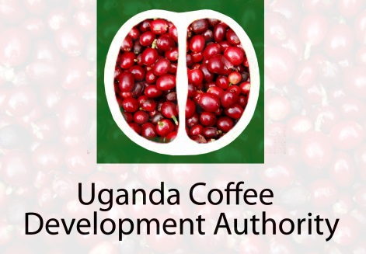

COFFEE MARKETING LICENSING / REGISTRATION GUIDELINES
EXPORT MARKETING
In order to qualify for Export of coffee, the trader shall be required to meet the following guidelines;-
- Provide full name of applicant and physical address.
- Company profile indicating Memorandum and Articles of Association, Shareholders and Management set –up.
- Provide a performance bond in Uganda Shillings equivalent to US $ 25,000 (Not Cash)
4. Provide evidence of access to a reprocessing factory capable of producing export grades.
5. Pay registration/License fee of Shs 1.5m/= per annum.
INTERNAL MARKETING.
- Provide full name of applicant and physical address.
- Indicate location of the store.
- Pay registration/license of Shs 50,000/= to Shs 250,000/= depending on capacity.
LICENSING AUTHORITY.
Uganda Coffee Development Authority (UCDA).
P.O Box 7267, Kampala, Uganda, Coffee House, Plot 35, Jinja Road, and Tel: 0414-233 073/0312-260470/1 Tel fax: 0414-232912. E-mail: md@ugandacoffee.org, ucda@ugandacoffee.org, URL: www.ugandacoffee.org

